Lesson One (Beginners )

What are Determiners?

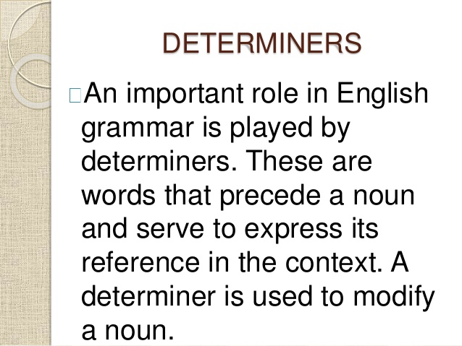
Many parts of speech, such as articles, demonstratives, quantifiers, and possessives, can act as a determiner.

Determiners are words that come before a noun and serve to modify the noun. Determiners modify nouns. Let’s take a look at the following sentence and identify the modifier:
- That dog is very fat.
Here 'that' is the determiner it tells or specifies exactly which dog the speaker is referring to.

These words are like the, a, an, this, some, either, my or whose. All determiners share some grammatical similarities:
- Determiners come at the beginning of a noun phrase, before adjectives.

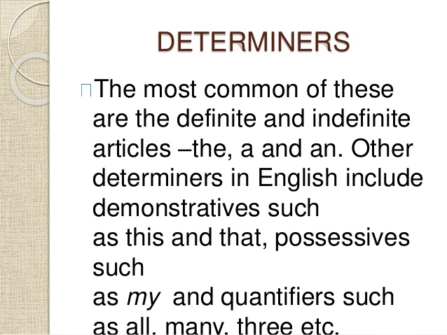
- If we do have more than one determiner, they go in a very specific order.

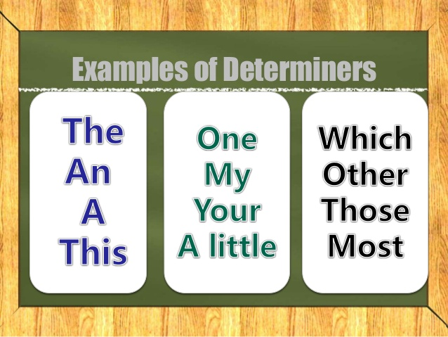

Look at these examples of noun phrases. The first word in each noun phrase is a determiner:
- the dog
- those people
- some brown rice
- either side of the road
- eleven bad boys
- his eldest child
- which bat
In English grammar, a determiner is a word or a group of words that specifies, identifies, or quantifies the noun or noun phrase that follows it.
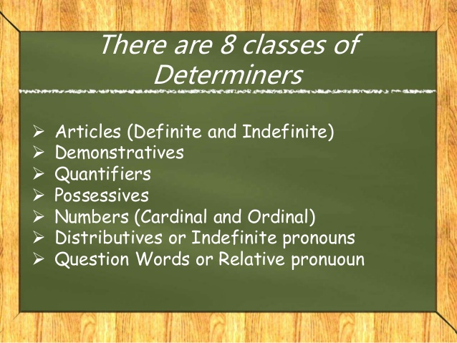

- Determiners include articles (a, an, the),
- Cardinal numbers (one, two, three...) and ordinal numbers (first, second, third...),
- Demonstratives (this, that, these, those),
- Partitives (some of, piece of, and others),
- quantifiers (most, all, and others),
- Difference words (other, another),
- Possessive determiners (my, your, his, her, its, our, their).

Rules on Multiple Determiners
When there is more than one determiner, follow these useful rules:
a) Place all and both in front of other determiners.
b) Place what and such in front of a and an in exclamations.
E.g. What an awful day! I've never seen such a crowd!
c) Place many, much, more, most, few, little after other determiners.
E.g. Her many articles successes made her famous. They have no more food. What little money I had is finished.​

Countable and uncountable Nouns
Some determiners work with countable nouns, and
some don't. For example, many is used with countable nouns, such as "The child with many toys." In contrast, you would not use much with countable nouns such as marbles.
But we can use much with work, for example in, "The students had much work to finish before final exams."
Other determiners work with either one, such as all: "The child had all the toys" and "The students had all the work to finish before final exams."

