Lesson One Parts of Speech

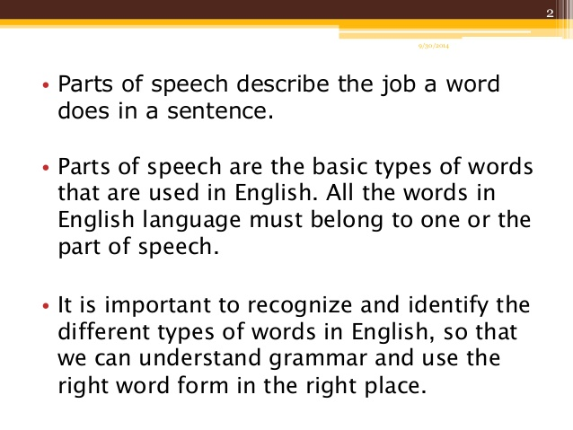
In English words can be grouped into 9 basic types called "parts of speech". It's quite important to recognize parts of speech. This helps you to analyze sentences and understand them. It also helps you to construct good sentences.

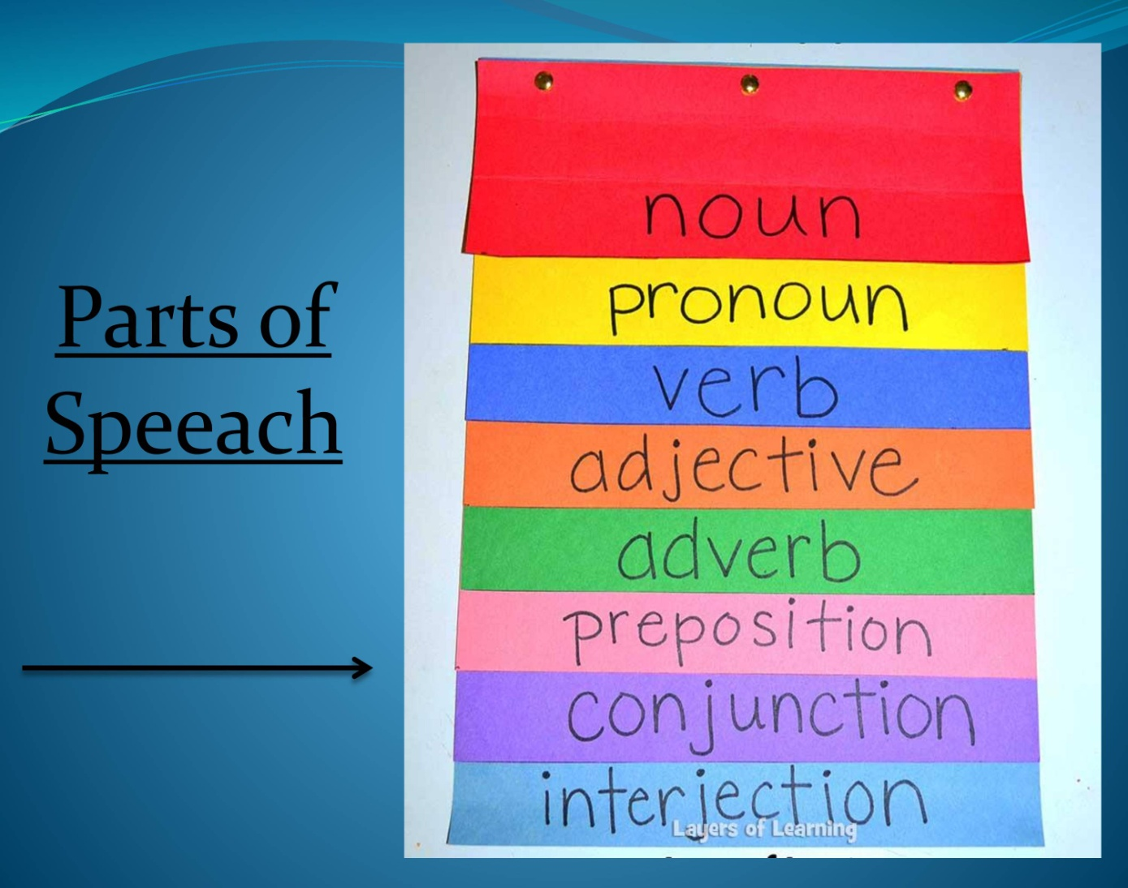

Parts of Speech Table
This is a summary of the 9 parts of speech*. You can find more detail if you click on each part of speech.
part of speech | function or "job" | example words | example sentences
Verb | action or state | (to) be, have, do, like, work, sing, can, must | EnglishClub is a web site. I like EnglishClub.
Noun | thing or person | pen, dog, work, music, town, London, teacher, John | This is my dog. He lives in my house. We live in London.
Adjective | describes a noun | good, big, red, well, interesting | My dogs are big. I like big dogs.
Determiner | limits or "determines" a noun | a/an, the, 2, some, many | I have two dogs and some rabbits.
Adverb | describes a verb, adjective or adverb | quickly, silently, well, badly, very, really | My dog eats quickly. When he is very hungry, he eats really quickly.
Pronoun | replaces a noun | I, you, he, she, some | Tara is Indian. She is beautiful.
Preposition | links a noun to another word | to, at, after, on, but | We went to school on Monday.
Conjunction | joins clauses or sentences or words | and, but, when | I like dogs and I like cats. I like cats and dogs. I like dogs but I don't like cats.
Interjection | short exclamation, sometimes inserted into a sentence | oh!, ouch!, hi!, well | Ouch! That hurts! Hi! How are you? Well, I don't know.

Parts of Speech Examples
Here are some examples of sentences made with different English parts of speech:

pronoun | verb | preposition | determiner | noun | adverb
She | ran | to | the | station | quickly.

pron. | verb | adj. | noun | conjunction | pron. | verb | pron.
She | likes | big | snakes | but | I | hate | them.
Here is a sentence that contains every part of speech:
interjection | pron. | conj. | det. | adj. | noun | verb | prep. | noun | adverb
Well, | she | and | my | young | John | walk | to | school | slowly.

In the table below you can see a few examples. Of course, there are more, even for some of the words in the table. In fact, if you look in a good dictionary you will see that the word "but" has six jobs to do:
- verb, noun, adverb, pronoun, preposition and conjunction!
word | part of speech | example
work | noun | My work is easy.
 | verb | I work in London.
but | conjunction | John came but Mary didn't come.
 | preposition | Everyone came but Mary.
well | adjective | Are you well?
 | adverb | She speaks well.
 | interjection | Well! That's expensive!
afternoon | noun | We ate in the afternoon.
 | noun acting as adjective | We had afternoon tea.

