Adjectives Lesson One
Adjectives describe or modify other words, making your writing and speaking much more specific, and a whole lot more interesting e.g. small, black, good etc. So adjectives tell us something about a person or a thing.

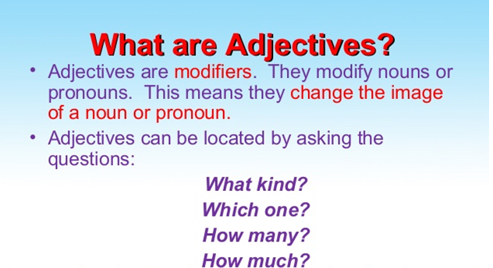

2. Adjectives can go after the following verbs:
- go
- Appear
- keep
- become
- get
- feel
- turn
When we speak about what something looks, smells, sounds and tastes – we use the adjective.
- I feel great.
- She looks beautiful.
- It seems possible.
- The food smells fantastic.

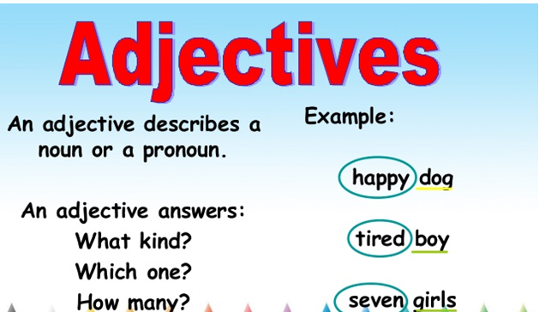

3. Adjectives answer the questions which one, what kind, and how much/many.
Which one: That bus has been in a crash.
What kind: We have black cat in our house.
How much: I ate too much fruit.

4. Can adjectives be used without nouns?
Yes, adjectives can be used without nouns. Use the definite article the:
- The poor = poor people
- The Cowrds= The Coward people
Here is another example with nationalities in the plural:
- The Indian= The Indian people.
- The English = The English people

5. Some Adjectives, ending in -ing and -ed

A) Here the adjective is put before the noun:
- Yesterday I read an interesting story.
- He has a boring job.
- They are excited people.

B) Here the adjective is put after the verb:
- I was amused by the statement.
- I get bored very often.
- The end of the story was quite exciting.
There are three forms of comparison:
- positive
- comparative
- superlative

1. Comparison with -er/-est
clean → cleaner → (the) cleanest

a) Adjectives with one syllable
positive | comparative | superlative
deep | deeperer | deepestest
new | newer | newest
cheap | cheaper | cheapest

b) Adjectives with two syllables and the following endings:

1.2.1. Adjectives with two syllables, ending in -y
positive | comparative | superlative
Happy=Ha+ppy | happier | happiest
Easy=ea+sy | easier | easiest
Pretty=Pr+tty | prettier | prettiest

C). Adjectives with two syllables
positive | comparative | superlative
clever | cleverer | cleverest
positive | comparative | superlative
simple | simpler | simplest
positive | comparative | superlative
dirty | dirtier | dirtiest | Change -y to -i (consonant before -y)
shy | shyer | shyest | Here -y is not changed to -i.  (although consonant before -y)

d) Comparison with more – most
All adjectives with more than one syllable (except some adjectives with two syllables – see above
positive | comparative | superlative
Difficult=diffi+cult | more difficult | (the) most difficult
Beautiful=Bauti+ful | More beautiful | (the)most beautiful

e) Irregular adjectives
positive | comparative | superlative | comment
good | better | best
bad | worse | worst
much | more | most | uncountable nouns
many | more | most | countable nouns
little | less | least
small | smaller | smallest

f). Some adjectives have two possible forms of comparison (-er/est and more/most).
positive | comparative | superlative
clever | cleverer / more clever | cleverest / most clever
common | commoner / more common | commonest / most common
likely | likelier / more likely | likeliest / most likely
pleasant | pleasanter / more pleasant | pleasantest / most pleasant
polite | politer / more polite | politest / most polite
quiet | quieter / more quiet | quietest / most quiet
simple | simpler / more simple | simplest / most simple
stupid | stupider / more stupid | stupidest / most stupid
subtle | subtler / more subtle | subtlest / most subtle
sure | surer / more sure | surest / most sure

